Homework 3

Representation Learning & Recommender Systems

1. **Experiment-1 Representation Learning Reconstruction embedding**
2. Algorithm

The optimization target is $Ο=-\sum_{r∈R}{\sum_{e∈r}{log⁡(P(e|r_{-e}))}}$. R is the set of all app usage records. Each record *r* contains 3 units *e*, the time-bin, the base station, and the used app. And the $r_{-e}=\{ο≠e|ο∈r\}$. We approximate $- log⁡(P(e|r_{-e}))$ with $J_{r}=-\log{σ\left(s\left(e, r_{-e}\right)\right)}-\sum_{k=1}^{K}{log⁡(σ(-s(ο_{k},r_{-e})))}$. And $σ\left(x\right)=\frac{exp(x)}{1+exp⁡(x)}$. $s\left(e,r_{-e}\right)=<I_{e},h_{e}>$, $h_{e}=\frac{1}{|r_{-e}|}\sum_{ο∈r_{-e}}{I_{ο}}$. $I_{e}$ is the D-dimensional embedding of unit 2. And we can use stochastic gradient descent to update each $I_{e}$.

$$\frac{∂J_{r}}{∂I_{e}}=(σ\left(s\left(e, r_{-e}\right)\right)-1)h_{e}$$

$$I_{e}←I_{e}-α\frac{∂J_{r}}{∂I_{e}}$$

1. Virtualization results
2. Plot the embeddings of different time bins (hours).

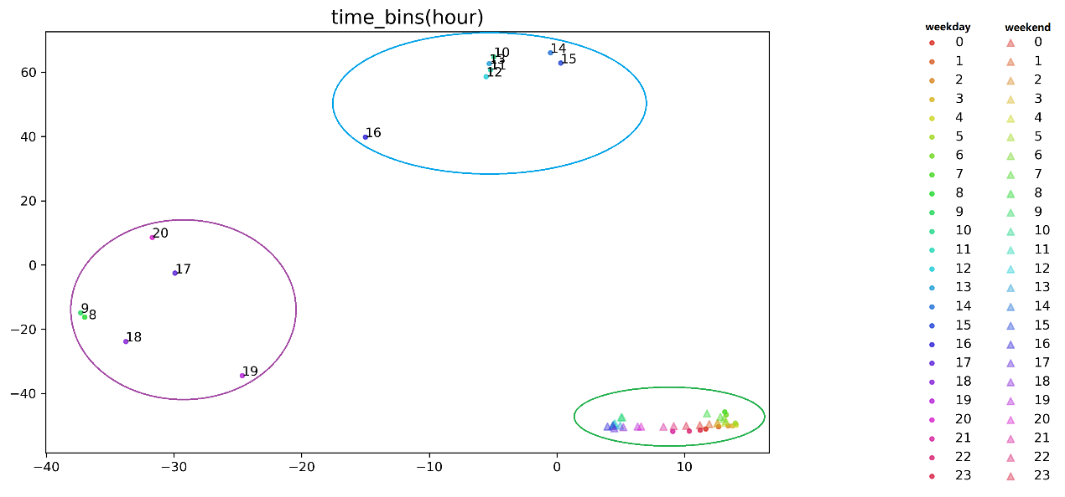

Interpretation /discussion: as seen from the plot, time-bins are perfectly separated into 3 clusters after embeddings according apps usages. The purple cluster includes morning rush hours (8-9) and evening rush hours (18-20) in weekday, which may represent rush time; The blue cluster includes working hours in weekday, which may represent working time; The green cluster includers all weekend hours and night hours in weekday, which may represent leisure time.

1. Plot the embeddings of apps of the category “Video”, “Finance”, “ Music.

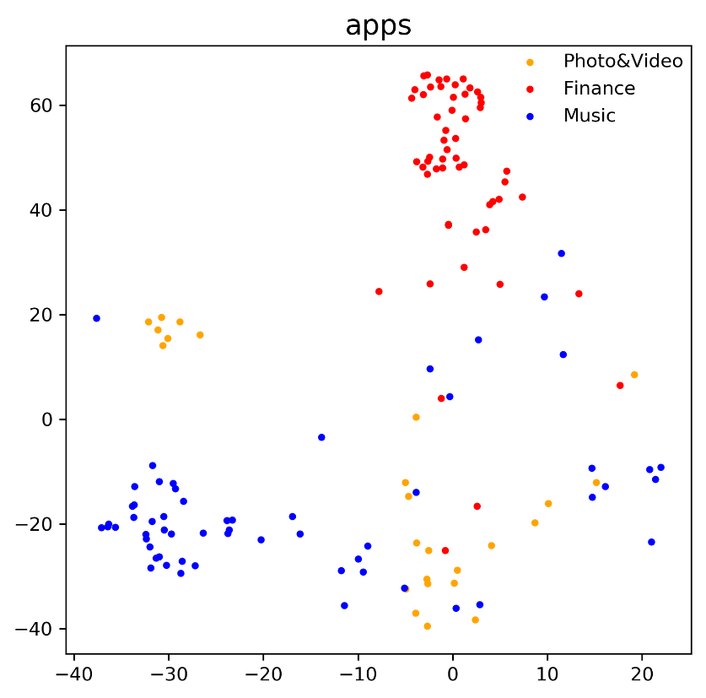

Interpretation /discussion : as seen from the plot, three kinds of apps are well separated, especially “Finance” to “Music” and “Photo&Video” to “Music”. But “Photo&Video” and “Music” are separated not so perfectly, which may due to “Photo&Video” and “Music” are similar, both using for entertainment.

1. Classification results

Focus on apps of “Photo&Video” and “Finance” and use SVM to divide them based on their embeddings.

The obtained accuracy: **0.679**

Interpretation /discussion：the reasons why obtained accuracy is not high are 1) the number of training samples are only 92 and 2) “Photo&Video” samples are much less than “ Finance”.

1. **Experiment-2 Use Collaborative Filtering to Recommend Apps to Users**
2. User-User Collaborative Filtering
3. Algorithm

we construct a matrix *r* for user(*u*)-app(*l*), and predict $r_{ul} by$ $r_{ul}=\frac{\sum_{v∈N(u)}{S_{uv}r_{vl}}}{\sum_{y∈N(u)}{S_{uv}}}$, $S_{uv}=sim\left(u,v\right)=\cos\left(r_{u},r_{v}\right)$, $N\left(u\right)$ is the set of k users most similar to *u* .

1. results

Calculate the RMSE RMSE= $\sqrt{\frac{1}{n}{(r_{ul}-\hat{r_{ul}})}^{2}}$, $\hat{r_{ul}}$ is the predicted value, 𝑛 is the number of predicted user app pair. Due to the time , I only use 0.2% user-app pair for plotting, then according the curve, I set k=12 and use 2% user-app pair to predict, and get the RMSE: **0.617**.

Plot the RMSE-𝑘 curve.

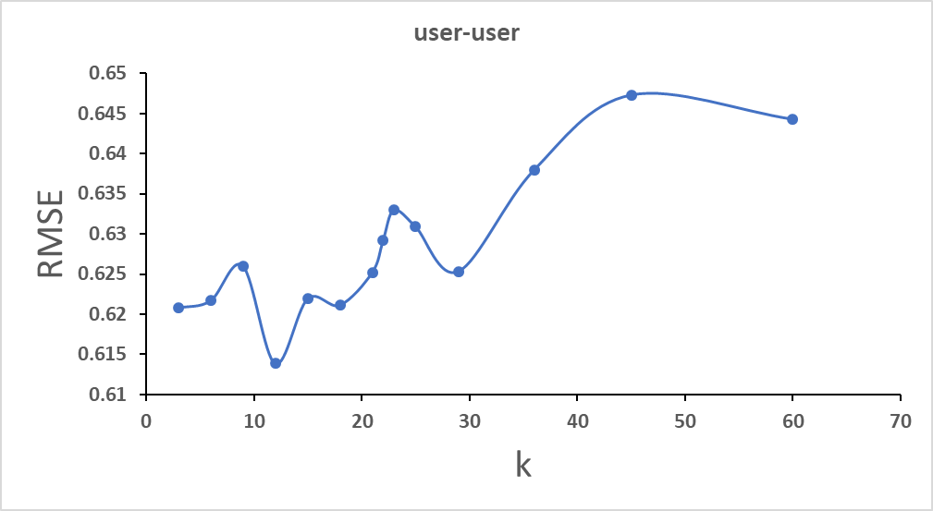

1. Interpretation /discussion :

as seen from RMSE-𝑘 curve , when k =12, RMSE has a minimum , and RMSE increases with the increasing of 𝑘 when k more than 12.

1. Item-Item Collaborative Filtering
2. Algorithm

we construct a matrix *r* for user(*u*)-app(*l*), and predict $r_{ul} by$ $r_{ul}=\frac{\sum_{j∈N(l)}{S_{lj}r_{uj}}}{\sum_{j∈N(l)}{S_{lj}}}$, $S_{lj}=sim\left(l,j\right)=\cos\left(r_{l},r_{j}\right)$, $N\left(l\right)$ is the set of k apps most similar to *l* .

1. results

Calculate the RMSE RMSE= $\sqrt{\frac{1}{n}{(r_{ul}-\hat{r_{ul}})}^{2}}$, $\hat{r_{ul}}$ is the predicted value, 𝑛 is the number of predicted user app pair. Due to the time , I only use 0.02% user-app pair for plotting, then according the curve, I set k=24 and use 0.2% user-app pair to predict, and get the RMSE: **0.297**

Plot the RMSE-𝑘 curve.

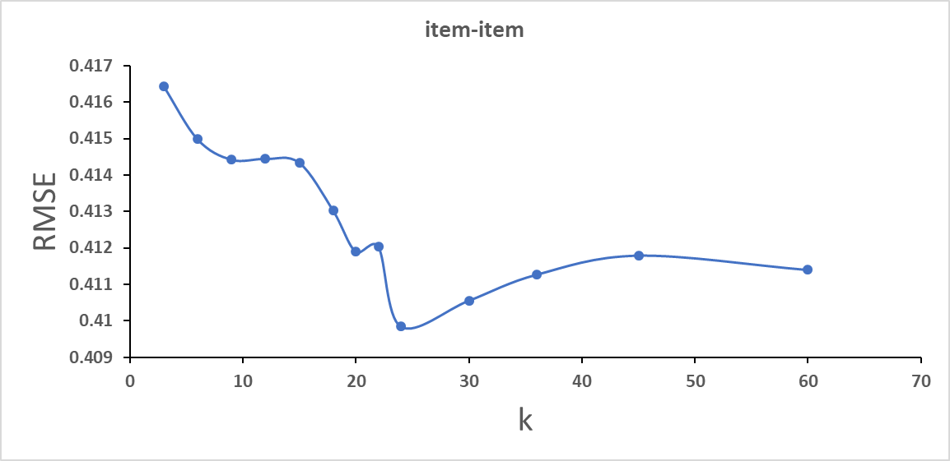

1. Interpretation /discussion : as seen from RMSE-𝑘 curve , RMSE decreases a little with the increasing of k ; When k=24, RMSE has a minimum.
2. Matrix Factorization (MF) based Collaborative Filtering
3. Algorithm

we construct a matrix *r* for user(*u*)-app(*l*), and predict $r_{ul}$ by $r_{ul}=q_{u}p_{l}$,

$q_{u}{ and p}_{l}$ are 𝑘 dimensional latent vectors for user 𝑢 and app 𝑙 . $q_{u}{ and p}_{l}$ are first initialized from SVD, and then updated by solving the optimization problem: $min\sum_{training set}{（{r_{ul}-q_{u}p_{l})}^{2}}+λ_{1}\sum_{u}{{|\left|p_{u}\right||}^{2}+}λ_{2}\sum_{u}{{|\left|q_{l}\right||}^{2}}$. We can use stochastic gradient descent to update $q_{u}{ and p}_{l}$.

1. results

Calculate the RMSE RMSE= $\sqrt{\frac{1}{n}{(r_{ul}-\hat{r_{ul}})}^{2}}$, $\hat{r_{ul}}$ is the predicted value, 𝑛 is the number of predicted user app pair. Due to “MemoryError” , I test 2% user-app pair in the dataset and get RMSE：**190.46 ,** elapsed time: ~2000s

•Data processing code

train.py ; trace_handler.py ; embed.py

•Collaborative filtering code

recommender_sysytem_CF.py

•Other analysis code

DimReduce.py ; classify.py ; visualizing.py